**Task#1**

using System;

namespace Salary1

{

class Program

{

static void Main(string[] args)

{

int Bs, grade;

string name;

double totalsalary;

Console.WriteLine("What's your name");

name=Console.ReadLine();

Console.WriteLine("what,s your basic salary");

Bs = Convert.ToInt32(Console.ReadLine());

Console.WriteLine("What's your grade");

grade = Convert.ToInt32(Console.ReadLine());

switch(grade )

{

case 17:

totalsalary = Bs + (0.05 * Bs) + (0.025 * Bs) +( 0.01 * Bs)- (0.075 * Bs);

Console.WriteLine("MR.{0} YOUR TOTAL SALARY IS {1}",name,totalsalary);

break;

case 18:

totalsalary = Bs * (0.055 * Bs) + (0.03 * Bs) * (0.015 * Bs) - (0.075 * Bs);

Console.WriteLine("\t\t Mr.{0} your total saiary is {1} ", totalsalary);

break;

case 19:

totalsalary = Bs * (0.06 * Bs) + (0.033 * Bs) * (0.015 * Bs) - (0.075 * Bs);

Console.WriteLine(" Mr.{0} your total salary is {1}",name,totalsalary);

break;

}

}

}

}

Output:

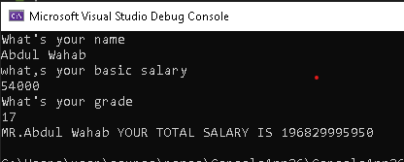

**Task 5**

using System;

namespace ConsoleApp27

{

class Program

{

static void Main(string[] args)

{

for (int i=1;i<= 3;i++)

{

Console.WriteLine("Chapter{0}",i);

for(int j=1;j<=5;j++)

{

Console.WriteLine("\t section {0}.{1}",i,j);

}

}

}

}

}

Output:

